Student Deliverables
1C-Bonus-C
01/29/2026
URL: firstpointand.click
NOTES:
Points to remember, per Sensei (Speech Ops)
DNS points to ingress TLS via ACM.
ALB handles secure public entry; private compute does the work.
WAF + alarms defend and alert
Student verification (CLI)
- Confirm hosted zone exists (if managed) aws route53 list-hosted-zones-by-name
--dns-name chewbacca-growl.com
--query "HostedZones[].Id"
jorun@Simpkij3421 MINGW64 ~/documents/theowaf/armageddon/armageddon_repo/armageddon_clone/1c_bonus_B (main)
$ aws route53 list-hosted-zones-by-name
--dns-name app.firstpointand.click
--query "HostedZones[].Id"
{
"HostedZones": [
{
"Id": "/hostedzone/Z0577510JJCMGIYZ7086",
"Name": "firstpointand.click.",
"CallerReference": "RISWorkflow-RD:1dab09cb-1032-4181-82e8-b14672092207",
"Config": {
"Comment": "HostedZone created by Route53 Registrar",
"PrivateZone": false
$ aws route53 list-hosted-zones-by-name
--dns-name app.firstpointand.click
--query "HostedZones[].Id"
{
"HostedZones": [
{
"Id": "/hostedzone/Z0577510JJCMGIYZ7086",
"Name": "firstpointand.click.",
"CallerReference": "RISWorkflow-RD:1dab09cb-1032-4181-82e8-b14672092207",
"Config": {
"Comment": "HostedZone created by Route53 Registrar",
"PrivateZone": false
"Id": "/hostedzone/Z0577510JJCMGIYZ7086",
"Name": "firstpointand.click.",
"CallerReference": "RISWorkflow-RD:1dab09cb-1032-4181-82e8-b14672092207",
"Config": {
"Comment": "HostedZone created by Route53 Registrar",
"PrivateZone": false
"Comment": "HostedZone created by Route53 Registrar",
"PrivateZone": false
"PrivateZone": false
},
"ResourceRecordSetCount": 4
}
],
"ResourceRecordSetCount": 4
}
],
}
],
],
"IsTruncated": false,
"MaxItems": "100"
}
"MaxItems": "100"
"MaxItems": "100"
"MaxItems": "100"
}
"MaxItems": "100"
"MaxItems": "100"
}
bash: --dns-name: command not found
bash: --query: command not found
NOTE: --dns-name: command not found and –query: command not found means either I have not run the command correctly or my Terraform is incorrect.
Retry below
____________________________________________________________________
SECOND ATTEMPT at CLI: Re- ran Command and received the following output:
jorun@Simpkij3421 MINGW64 ~/documents/theowaf/armageddon/armageddon_repo/armageddon_clone/1c_bonus_B (main)
jorun@Simpkij3421 MINGW64 ~/documents/theowaf/armageddon/armageddon_repo/armageddon_clone/1c_bonus_B (main)
$ aws route53 list-hosted-zones-by-name \
--dns-name firstpointand.click \
--query "HostedZones[].Id"
[
"/hostedzone/Z0577510JJCMGIYZ7086"
]
- (Screenshot)
Confirm hosted zone exists (if managed) aws route53 list-hosted-zones-by-name
--dns-name chewbacca-growl.com
--query "HostedZones[].Id"

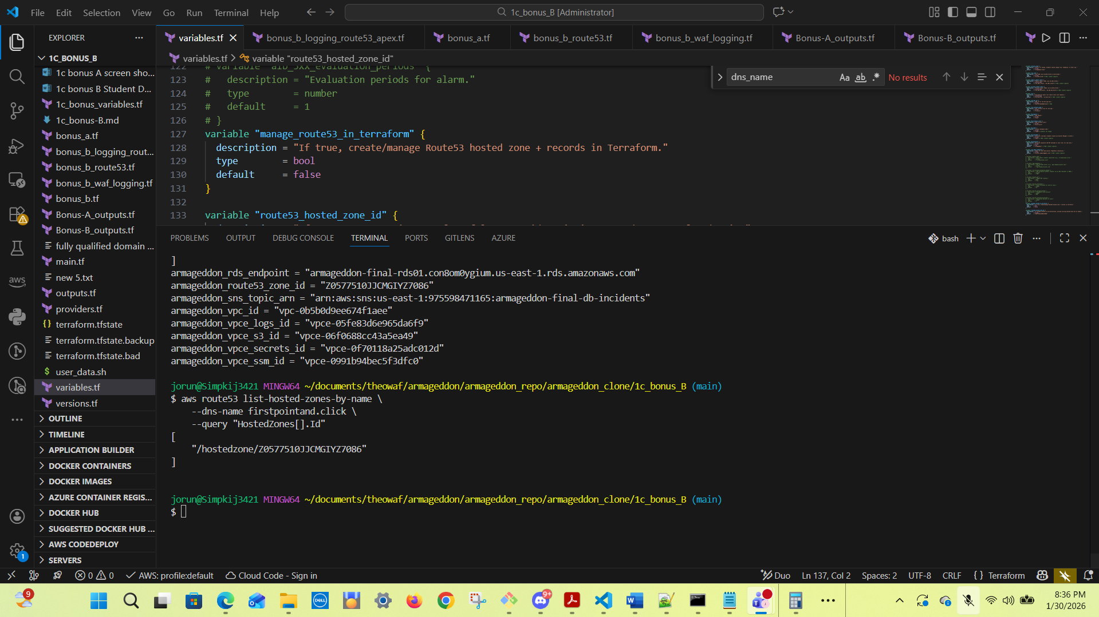

- Confirm app record exists aws route53 list-resource-record-sets
--hosted-zone-id <ZONE_ID>
--query "ResourceRecordSets[?Name=='app.chewbacca-growl.com.']"
jorun@Simpkij3421 MINGW64 ~/documents/theowaf/armageddon/armageddon_repo/armageddon_clone/1c_bonus_B (main)
$ aws route53 list-resource-record-sets --hosted-zone-id /hostedzone/Z0577510JJCMGIYZ7086 --query "ResourceRecordSets[?Name=='app.firstpointand.click.']"
[
{
"Name": "app.firstpointand.click.",
"Type": "A",
"AliasTarget": {
"HostedZoneId": "Z35SXDOTRQ7X7K",
"DNSName": "armageddon-final-alb01-243733139.us-east-1.elb.amazonaws.com.",
"EvaluateTargetHealth": true
}
}
]

aws route53 list-resource-record-sets \
--hosted-zone-id "/hostedzone/Z0577510JJCMGIYZ7086" \
--query "ResourceRecordSets[?Name=='app.firstpointand.click.']"
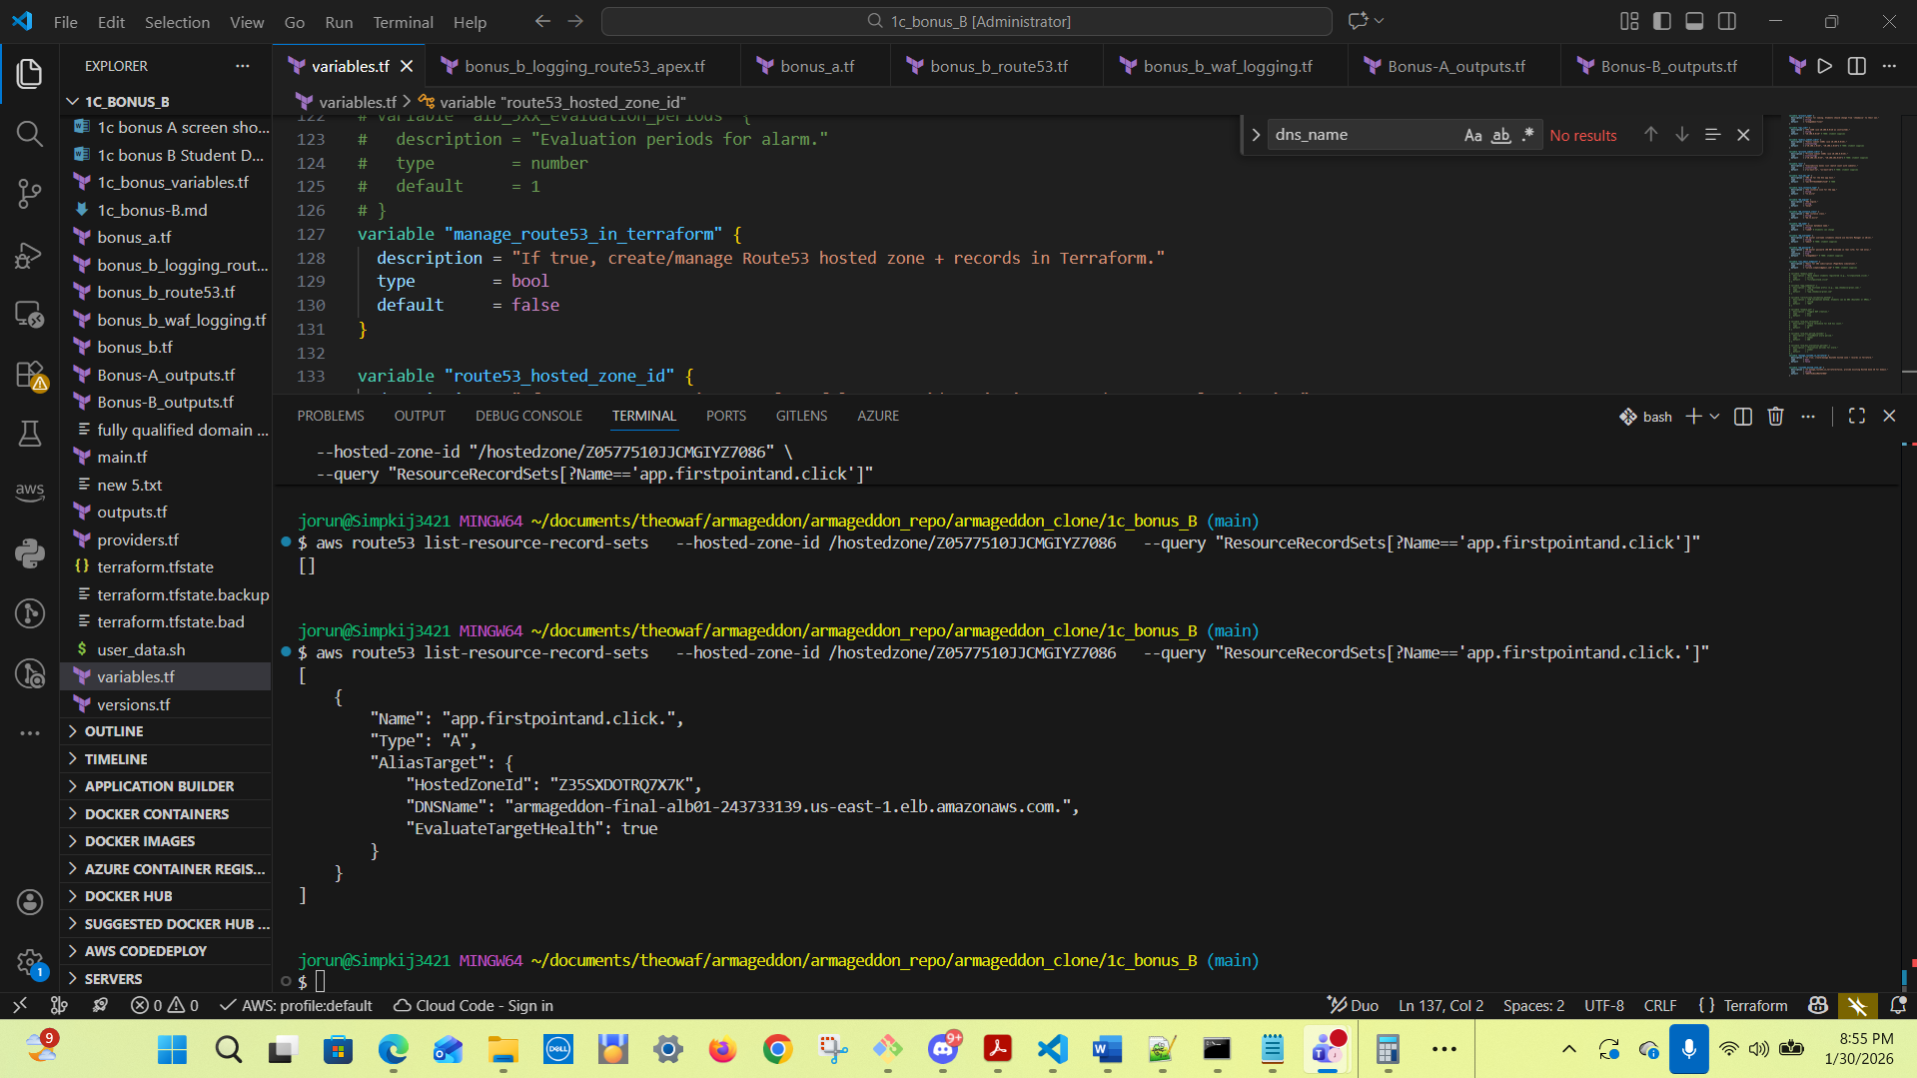

- Confirm certificate issued aws acm describe-certificate
--certificate-arn <CERT_ARN>
--query "Certificate.Status"
Expected: ISSUED
jorun@Simpkij3421 MINGW64 ~/documents/theowaf/armageddon/armageddon_repo/armageddon_clone/1c_bonus_B (main)
$ aws acm describe-certificate \
--certificate-arn arn:aws:acm:us-east-1:975598471165:certificate/1bfd3a45-c223-47ae-9717-2c8692a9d615 \
--query "Certificate.Status"
"ISSUED"
$ aws acm describe-certificate \
--certificate-arn arn:aws:acm:us-east-1:975598471165:certificate/1bfd3a45-c223-47ae-9717-2c8692a9d615 \
--query "Certificate.Status"
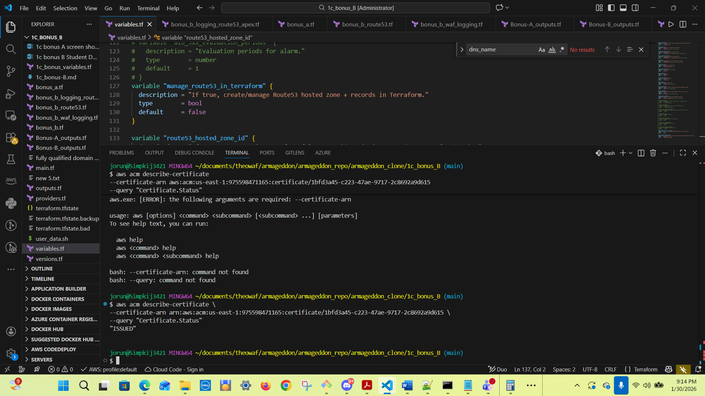

- Confirm HTTPS works curl -I https://app.chewbacca-growl.com
curl -I https://app.firstpointand.click
Expected: HTTP/1.1 200 (or 301 then 200 depending on your app)

jorun@Simpkij3421 MINGW64 ~/documents/theowaf/armageddon/armageddon_repo/armageddon_clone/1c_bonus_B (main)
$ curl -I https://app.firstpointand.click
curl: (35) schannel: next InitializeSecurityContext failed: CRYPT_E_NO_REVOCATION_CHECK (0x80092012) - The revocation function was unable to check revocation for the certificate.

jorun@Simpkij3421 MINGW64 ~/documents/theowaf/armageddon/armageddon_repo/armageddon_clone/1c_bonus_B (main)
$ curl -I https://firstpointand.click
curl: (6) Could not resolve host: firstpointand.click
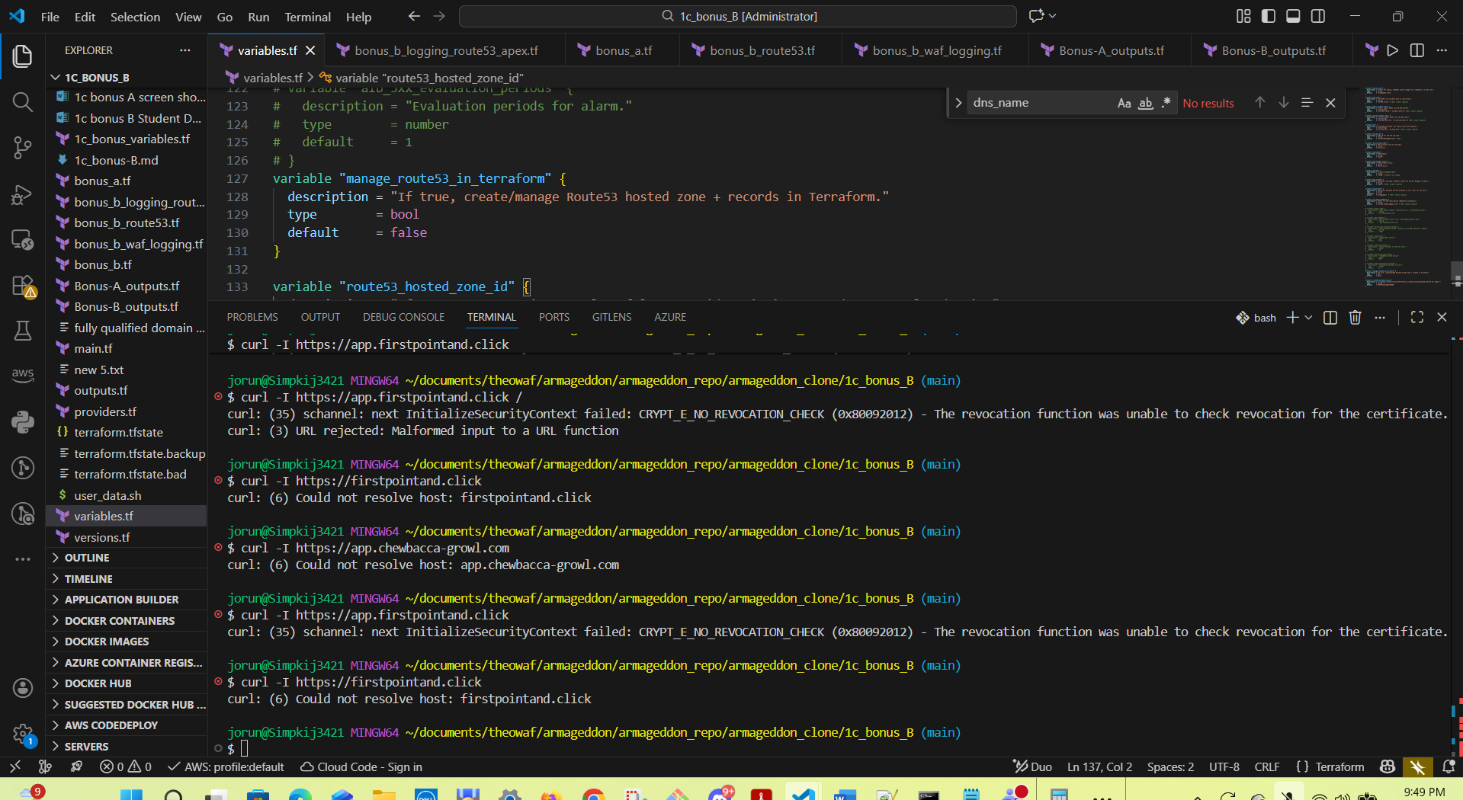
NOTE: There is an issue running this command in WINDOWS
ERROR:
curl -I https://app.firstpointand.click curl: (35) schannel: next InitializeSecurityContext failed: CRYPT_E_NO_REVOCATION_CHECK (0x80092012) - The revocation function was unable to check revocation for the certificate.

When I researched using the curl command with in VS Code, I received the following:
This error is not a problem with your AWS certificate or your domain. It’s a Windows-specific curl + Schannel quirk: Windows curl tries to check the certificate’s revocation (CRL/OCSP), but your system cannot reach the revocation servers. Browsers succeed because they use different TLS stacks, but curl on Windows uses Schannel, which is stricter and fails when revocation checks can’t be performed.
Your site https://app.firstpointand.click is almost certainly fine — this is a local Windows curl issue, not an AWS issue.
What This Error Means
Windows curl is saying:
“I can’t check whether the certificate has been revoked.”
This happens when:
- Your network blocks OCSP/CRL endpoints
- A proxy/VPN intercepts TLS
- Windows certificate revocation checking is disabled or broken
- Corporate/ISP filtering interferes
- You’re behind a firewall that blocks outbound revocation URLs
Browsers bypass or soft-fail this check. Windows curl hard-fails.
(see next page below for successful command in BASH Shell)

Second attempt: Ran the curl in the BASH shell (successful)
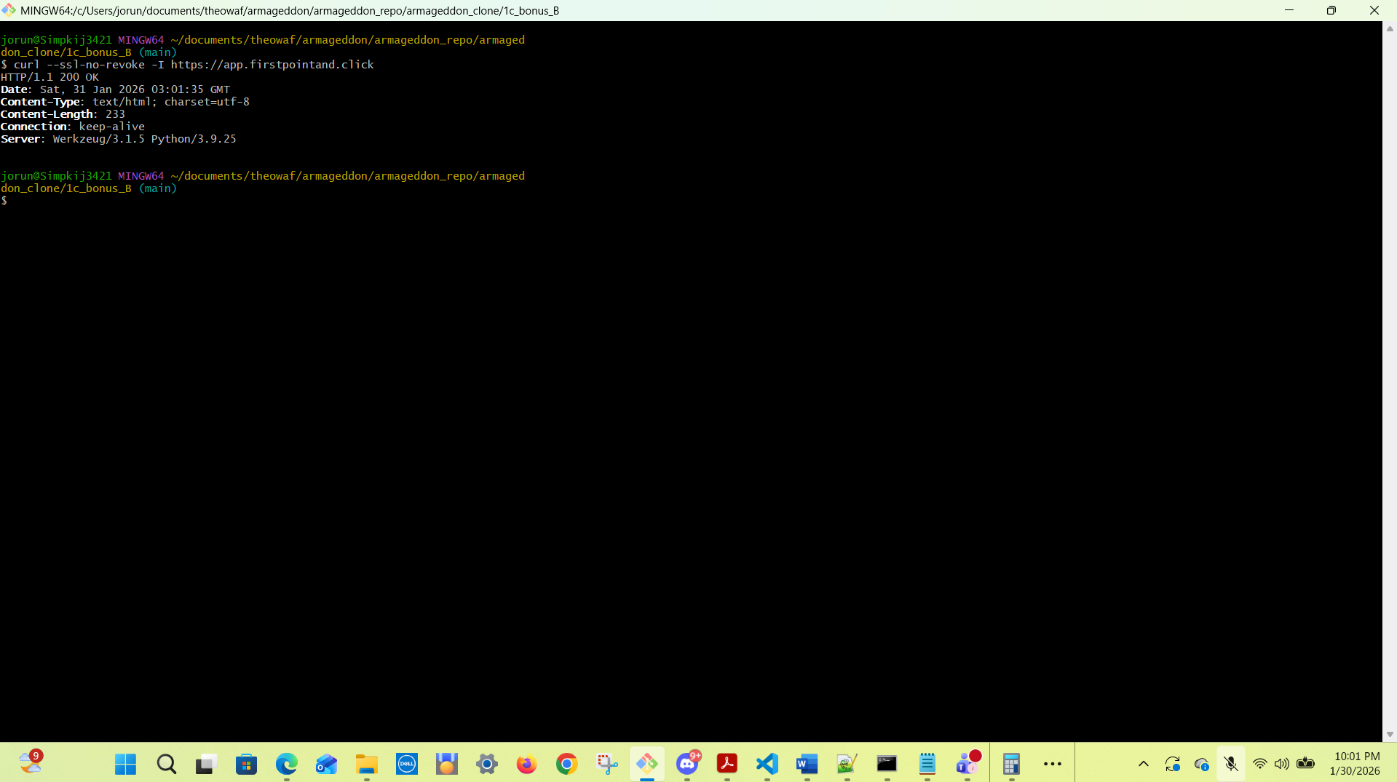
jorun@Simpkij3421 MINGW64 ~/documents/theowaf/armageddon/armageddon_repo/armageddon_clone/1c_bonus_B (main)
$ curl --ssl-no-revoke -I https://app.firstpointand.click
HTTP/1.1 200 OK
Date: Sat, 31 Jan 2026 03:01:35 GMT
Content-Type: text/html; charset=utf-8
Content-Length: 233
Connection: keep-alive
Server: Werkzeug/3.1.5 Python/3.9.25

jorun@Simpkij3421 MINGW64 ~/documents/theowaf/armageddon/armageddon_repo/armageddon_clone/1c_bonus_B (main)
$
NOTES:
Points to remember, per Sensei (Speech Ops)
DNS points to ingress TLS via ACM.
ALB handles secure public entry; private compute does the work.
WAF + alarms defend and alert

URL: app.firstpointand.click
